‘I am the vine.’
Reading: John 15:5-8
Jesus said, “I am the vine. You are the branches. If you remain joined to me, and I to you, you will bear a lot of fruit. You can’t do anything without me. If you don’t remain joined to me, you are like a branch that is thrown away and dries up. Branches like those are picked up. They are thrown into the fire and burned. If you remain joined to me and my words remain in you, ask for anything you wish. And it will be done for you. When you bear a lot of fruit, it brings glory to my Father. It shows that you are my disciples.”

Thought about the reading
A vine is a plant that grows grapes. It has one big stalk that grows out of the ground. The branches grow out of the stalk. The grapes grow on the branches.
Jesus said that he was like the vine (the stalk). We are like the branches growing out of him. The vine gets all the goodness it needs from the roots. The goodness goes up the vine and into the branches. Then they are able to grow lovely bunches of grapes.
What fruit do Christians produce? The fruit in our lives is loving God and our neighbours, helping people and telling them about Jesus.
If we want to grow as Christians and have fruit in our lives, we need to be joined to Jesus. He will give us everything we need. Without him we will not be able to produce fruit. We will not be able to love God or other people as he wants us to.

Prayer
Lord Jesus, thank you that you are like a vine. If I am joined to you, you will give me everything I need to love you and people round me.
Please help me to stay joined to you. Help me to produce lots of fruit in my life. Help me to love you and to love other people.
Amen
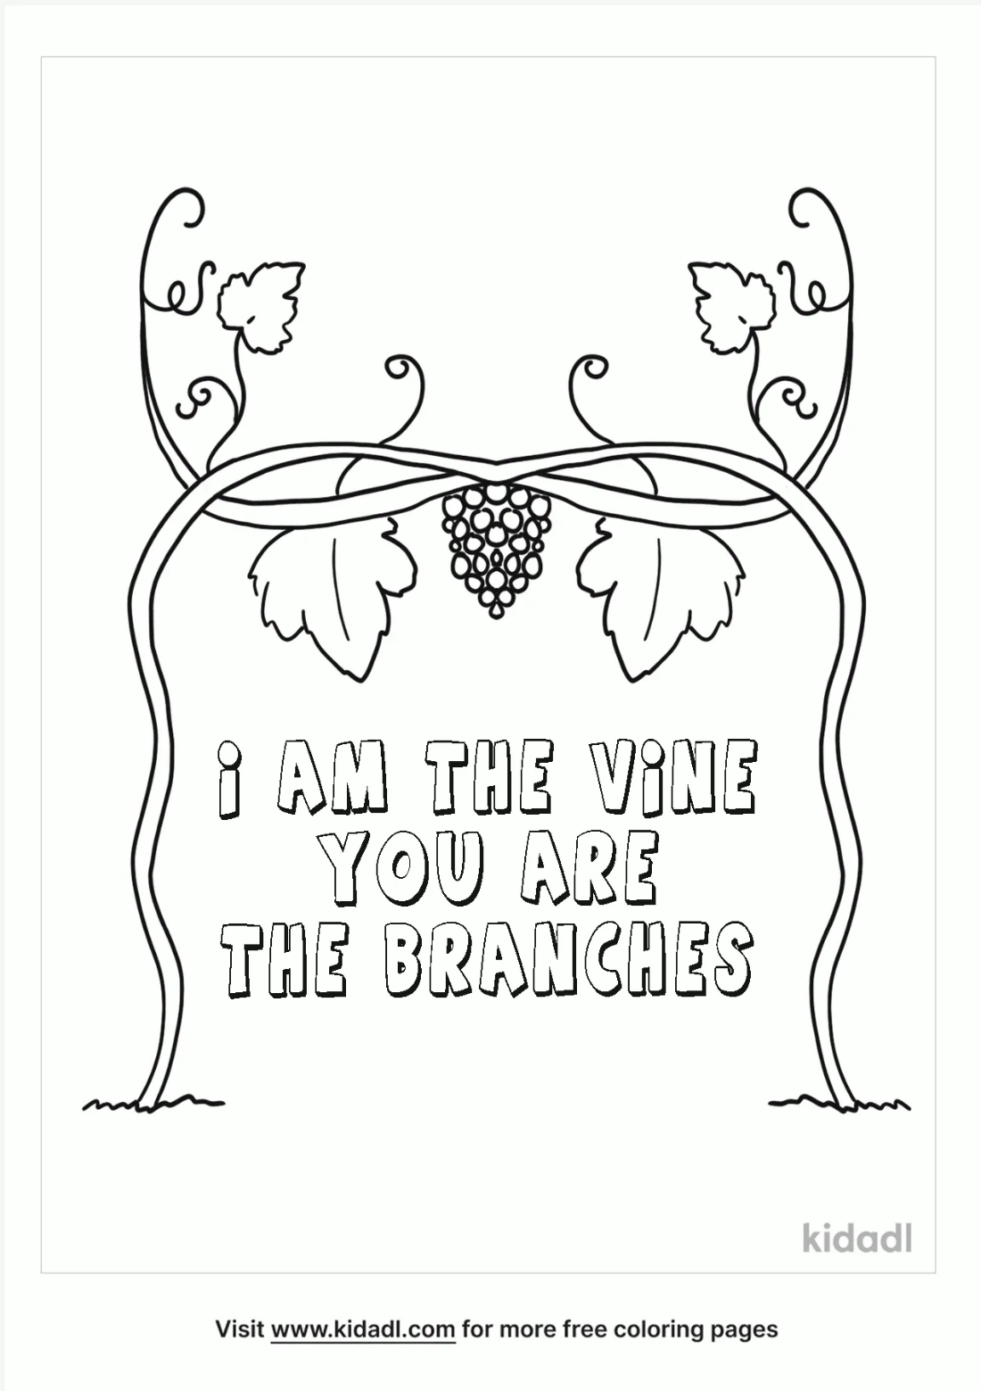

Cambridge Causeway

Autumn 2023
Bible Study notes

Jesus said ‘I am…’
2. I am the vine
By Chrissy Cole

